1.(1.sql) .Write a query to display total value of each order from 1/12/1996 to 31/12/1996 as follows / Note: Total value = sum of all (UnitPrice \* Quantity).

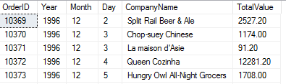

2.(2.sql) .An order will be taxed 10% if its freight cost is larger than or equal to $100.Otherwise, an order will be taxed 5% if its freight cost is smaller than $100. Write a query to show the freight with taxes of orders placed between 1/1/1997 and 31/1/1997 as follows, by ascending order of order ID as follows /

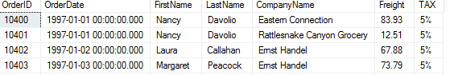

3.(3.sql) .Write a query to display number of product of each category as follows /

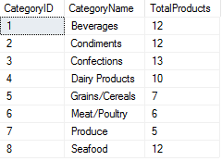

4.(4.sql) . Write a query to display the list of expensive products from 5th to 10th as follows. /

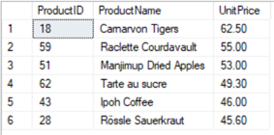

5.(5.sql) .Write a query to display the categories which has minimum total orders. /



6.(6.sql) .Write a query to display the customer and their number of orders, sorted by the number of orders as follows /

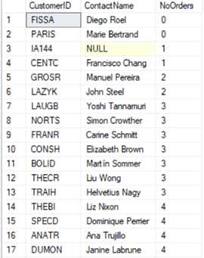

7.(7.sql) . Write a query to display the 5 most recently recruited new employees as follows /

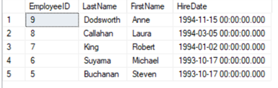

8.(8.sql) . Write a query to display 5 most expensive products and 5 cheapest products as follows /

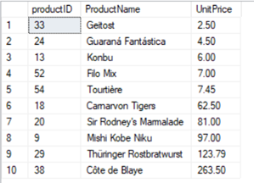

9.(9.sql) . Write a query to display all customers that placed orders in December 1996, by their contact title descending order. /

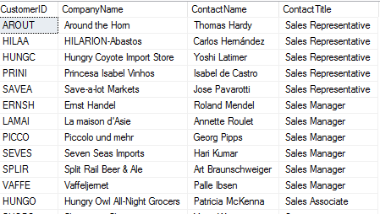

10.(10.sql) . Write a query to display customers and sum of total values of their orders as below. /

